CSD201 PE INSTRUCTIONS
Students are ONLY allowed to use:
- Materials on his / her computer (including JDK, NetBeans...).
- For distance learning: Google Meet, Hangout (for Exam Monitoring Purpose).
Follow the steps below to complete PE:
- Create a folder named CSD_given (1). Down load given files to (1).
- Steps to do question 1 (do the same for questions 2 and 3):
Open NetBeans, create a new project named Q1 (or Q1X, Q1Y, ...). In the “Name and Location” window change “q1.Q1” to “Main” as below:
Change 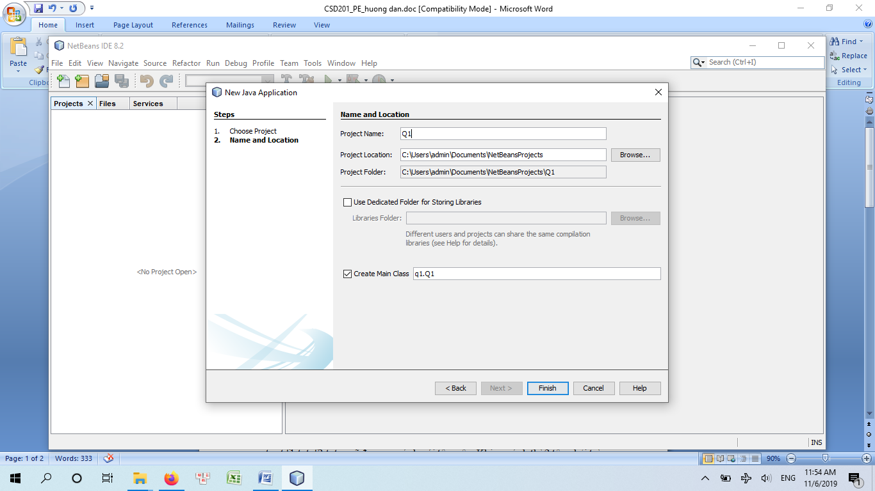 to 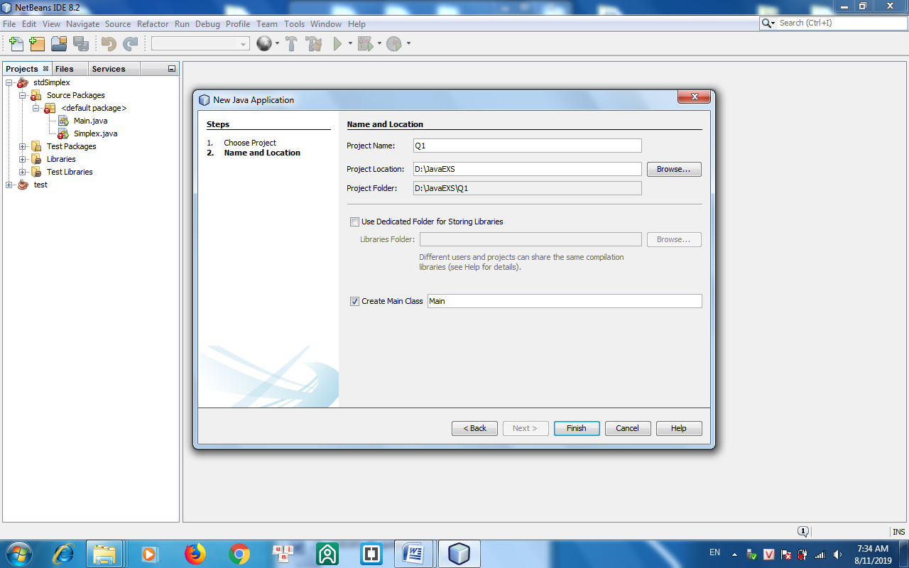
Close Main.java file. Copy all files in the given Q1 folder into src folder (overwriting Main.java file), then copy data.txt file to the project folder (outside of src).
- Submission: Create a folder with arbitrary name, e.g. CSD_PE (2). Create subfolders according to your coded projects, e.g. if you have edited and want to submit 3 projects Q1, Q2 and Q3 then create 3 subfolders Q1R, Q2R and Q3R inside (2), and copy
MyList.java from Q1\src to Q1R  BSTree.java from Q2\src to Q2R  Graph.java from Q3\src to Q3R | 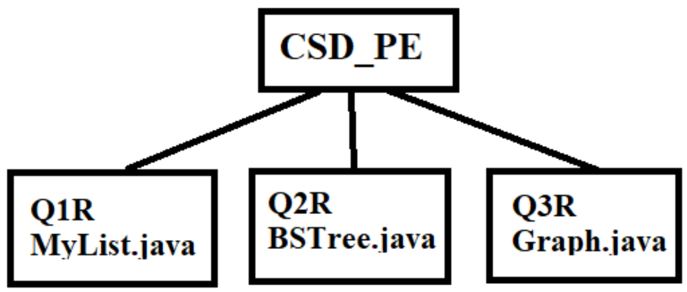
When submiting, you select the folder (2) and click Submit button (do not need to compress it). Do not submit a project you have not written code inside it.
- Do not use accented Vietnamese when writing comments in program.
- The version of Java being used must be 1.7 or 1.8
If at least one of the above requirements is not followed, the exam will get ZERO.

Question 1: (4 marks)
In this question you should complete some methods in MyList.java file.
The class Car with 2 data members: owner and price is given and you do not need to edit it. The MyList class is a linked list of Car objects. The following methods should be completed:

- void addLast(String xOwner, int xPrice) - check if xOwner.charAt(0) = 'B' or xPrice>100 then do nothing, otherwise add new car with owner=xOwner, price=xPrice, price=xPrice to the end of the list. (price can get arbitrary value, even negative).

- void f1() – This method is used to test the addLast methode above. You do not need to edit this function. Output in the file f1.txt must be the following:
(A,9) (C,7) (D,2) (E,6) (F,4)

- void f2() – There is a given objects x. You should write statements so that x will be the first element of the list. Output in the file f2.txt must be the following:
(C,9) (D,6) (E,8) (F,2) (I,6)
(X,1) (C,9) (D,6) (E,8) (F,2) (I,6)

- void f3() – Suppose the list contains at least 3 elements. Delete the first node having price=5. Output in the file f3.txt must be the following:
(C,9) (D,5) (E,3) (F,5) (I,6)
(C,9) (E,3) (F,5) (I,6)

- void f4() – Sort the list ascendingly by price. Output in the file f4.txt must be the following:
(C,9) (D,6) (E,5) (F,13) (I,2) (J,1)
(J,1) (I,2) (E,5) (D,6) (C,9) (F,13)

Question 2: (4 marks)
In this question you should complete some methods in BSTree.java files.
The class Car with 2 data members: owner and price is given and you do not need to edit it. The BSTree class is a binary search tree of Car objects. The variable price is the key of the tree. The following methods should be completed:

- void insert(string xOwner, int xPrice) - check if xOwner.charAt(0) = 'B' or xPrice>100 then do nothing, otherwise insert new car with owner=xOwner, price=xPrice to the tree.

- void f1() – You do not need to edit this function. Your task is to complete the insert(...) function above only. Output in the file f1.txt must be the following:
(A,5) (C,2) (E,4) (G,3) (D,6) (F,7)
(C,2) (G,3) (E,4) (A,5) (D,6) (F,7)

- void f2() – Perform pre-order traversal from the root but display to file f2.txt nodes having price in the interval [3,5] only. Hint: Copy the function preOrder(...) to preOrder2(...) and modify it. Output in the file f2.txt must be the following:
(C,6) (D,2) (F,4) (H,3) (I,5) (E,8) (G,7)
(F,4) (H,3) (I,5)

- void f3() – Perform breadth-first traversal from the root and delete by copying the first node having both 2 sons and price < 7. Output in the file f3.txt must be the following:
(C,8) (D,6) (E,9) (F,2) (G,7) (H,1) (I,3) (J,5) (K,4)
(C,8) (J,5) (E,9) (F,2) (G,7) (H,1) (I,3) (K,4)

- void f4() – Perform breadth-first traversal from the root and find the first node p having left son and price < 7. Rotate p to right about its’ left son. Output in the file f4.txt must be the following:
(C,8) (D,6) (E,9) (F,2) (G,7) (H,1) (I,3) (J,5) (K,4)
(C,8) (F,2) (E,9) (H,1) (D,6) (I,3) (G,7) (J,5) (K,4)

Question 3: (2 marks)
In this question you should complete some methods in Graph.java file.

The class Graph is the implementation of a graph. The following methods should be completed:
- void f1() - Perfom depth-first traversal (to the file f1.xt) from the vertex i=1 (the vertex B) but display vertices with their deegrees in bracket. Hint: copy depth(...) to depth2(...) and modify the latter one. Content of the output file f1.txt must be:
B G A E F I C H D
B(1) G(2) A(4) E(3) F(3) I(3) C(1) H(2) D(1)

- void f2() – Apply the Dijkstra’s shortest path algorithm to find the shortest path from the vertex 0 (A) to the vertex 4 (E). (Note that in the weighted matrix, the value 999 is considered as infinity). Write 2 lines into the file f6.txt. The first line contains the list of vertices in the shortest path. The second lines contains shortest distances to the vertices in the first line. Content of the output file f2.txt must be:
A C F E
0 9 11 20

- void f3() – Supposed the given graph has Euler's cycle. Apply the pseudocode in the Graph.java file to write statements to find the Euler's cycle from the vertex 1 (B). Output in the file f3.txt must be the following:
B D E D C B E G F A B

